**PRO DEFENSIO CHRISTIANITATIS**

**Santiago de Chile, 27 april 2017 – Filip Dewinter**

Buenas tardes a todos,

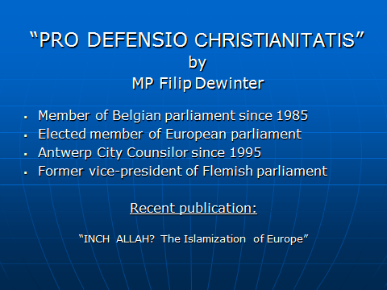

I would like to thank Controversia TV for this wonderful opportunity to share my thoughts with you today.

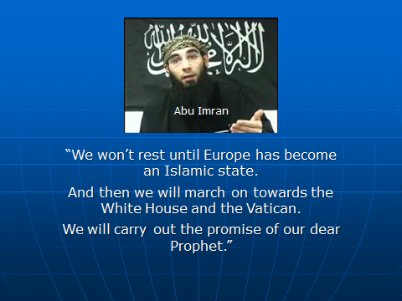

I would like to start off with the words of the leader of a Belgian Muslim Organization Abu Imran, the leader of Sharia4Belgium, who said in an interview: “*We won’t rest until Europe has become an Islamic state. And then we will march on towards the White House and the Vatican. We will carry out the promise of our dear Prophet.*”

Dear friends,

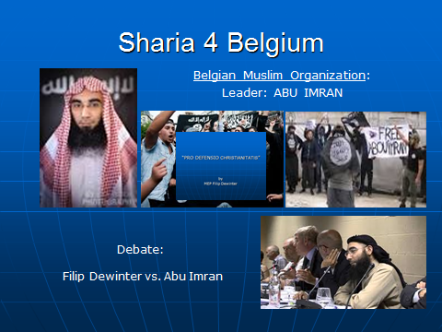

Abu Imran is unfortunately not just an isolated nutcase. He is the leader of an organisation who send about 80 militant Belgian Muslims to Syria to fight with IS. Members of Sharia4Belgium were responsible for the Paris and Brussel terrorism attacks. Western civilization faces extinction because of mass immigration, multiculturalism and islamization.

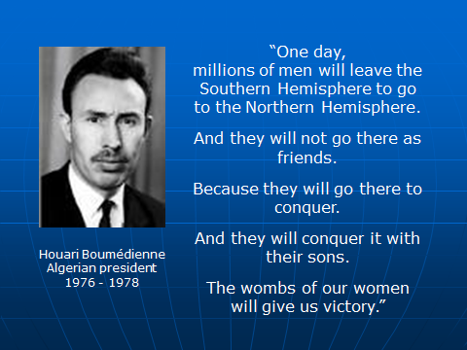

Already in 1974, the former Algerian President Houari Boumédienne prophetically addressed the general assembly of the United Nations: “*One day, millions of men will leave the Southern Hemisphere to go to the Northern Hemisphere. And they will not go there as friends. Because they will go there to conquer. And they will conquer it with their sons. The wombs of our women will give us victory.*” Boumedienne’s prediction is steadily becoming true.

Since the first non-European immigrant workers entered Europe in the 1960’s, the number of third world immigrants on European soil has increased rapidly.

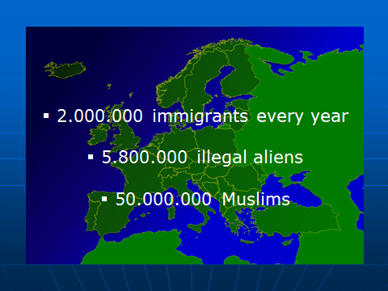

Through family reunification, marriage migration or the asylum procedure, each year about 2 million non-European fortune-seekers obtain a residence permit from the European Union. In 2015, more than 1 million asylum seekers entered Europe.

On top of legal immigration, there is also a massive problem with illegal immigration. A European Parliament report estimated that between 5 and 8 million illegal aliens reside in the European Union. More than 50 million Muslims live in Europe yet.

Governments all over the West have lost their grip on immigration. The political elite refuse to call a halt to immigration, to eliminate abuses of the system and to take firm measures against illegal immigrants, because of naivety, fear for being accused of ‘racism’ or a shared leftist ideological agenda..

There is no longer a such thing as ‘controlled immigration’. The immigration stream has become an immigration invasion, a mass phenomenon that is replacing the indigenous population - all too often with cultural maladjusted immigrants.

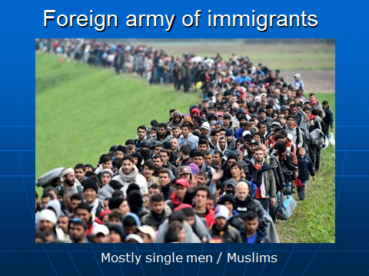

If we do not tighten our immigration laws, the mass immigration of today will just be the tip of the iceberg. Right now, Europe is confronted by a wave of two million immigrants every year. Within a few decades, this could turn into an uncontrollable tsunami of tens of millions fortune seekers per year, who are willing to do whatever it takes to set foot in the European Eldorado.

The next generations of Europeans, our children and grandchildren, will have to fight for the survival of our Western culture. These existential problems are not new. The foundations of our European civilization were laid more than 2.000 years ago by the ancient Romans and Greeks and were under pressure already several times throughout history.

Dear friends,

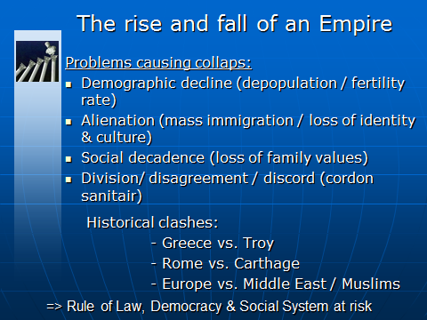

The classical civilizations of Greece and Rome collapsed because of exactly the same problems as the ones Europe is facing at the moment. There are clear parallels between what happened then and is now happening in my home country. Greece and Rome underwent, just as Europe currently, demographic decline, alienation, social decadence and division.

If we don't wake up, pay attention and take action against these lethal influences, soon the European civilization will come to an end.

As soon as individualism, mercantilism and materialism take the upper hand and there is no longer respect for law and order, nor for the traditional values, a civilization ends.

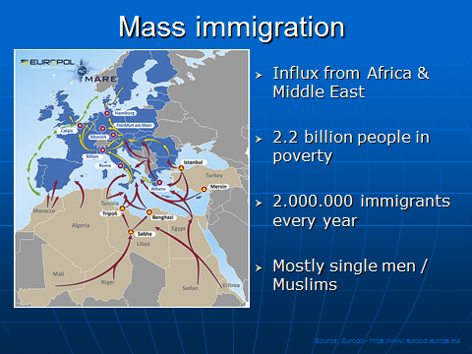

Currently, there is a growing flow of people from Africa and the Middle East to Europe.

Multiculturalists claim that migration is a human right and that allowing migrants into Europe is a humane gesture. They lose sight of the fact that it is simply impossible for Europe to help the approximately 2.2 billion people in the world who live in poverty.

This would have a devastating effect on the European society and our social system would immediately collapse.

Two millennia after Greece and Rome the illusion of multiculturalism is again on the verge or destroying a civilization. The delusions of ‘world citizenship’ and ‘multi culture’, play an important role in the decline of Europe.

Europeans are obligated immersed in a multiracial ‘multi culture’. In Europe the prevailing leftist political elite has contempt for every reference to identity. It is a political taboo in Europe to confirm your European or Western identity.

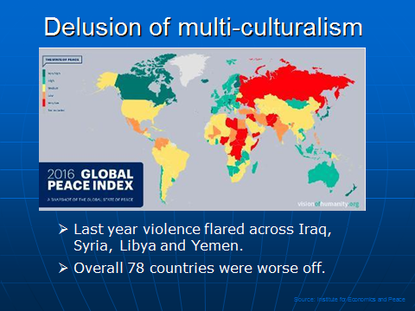

The multicultural ideology assumes that different civilization standards and levels can live peacefully with each other on the same territory. However, history has already proven that this always leads to bloody clashes after which one culture, the dominant one, gets the upper hand over the weakest.

Currently there are several similar bloody conflicts in the world, from Malaysia to Rwanda, from the Balkan to South Africa.

Dear friends,

While immigration and a very high birth rate cause the number of non-European immigrants in Europe to rapidly increase, Europe is on the verge of extinction. With the exception of Albania, which consist mainly of Muslims, not a single European country has a birth rate that is high enough to maintain the population. The native Europeans threaten to halve within less than 50 years.

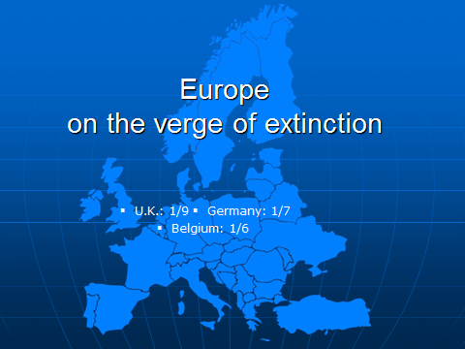

Because of the continuously growing immigration streams towards Europe and the high birth rate among immigrants, the ethnic composition is dramatically changing. In Germany, one out of seven of the 82 million inhabitants is from foreign descent. 16 per cent of France’s population is from foreign descent. In the United Kingdom, one out of nine people is born abroad. In the Netherlands, one out of five people is from foreign descent. In Belgium, one sixth of the population consists of immigrants. Brussels, the capital of Europe, already consists for 70 per cent of immigrants, a percentage that will rise to 85 per cent by 2020. In my own city Antwerp, 40 per cent of the population is from foreign descent. By 2020, this will be 55 per cent. In my hometown Antwerp, 52% of the schoolchildren are Muslims.

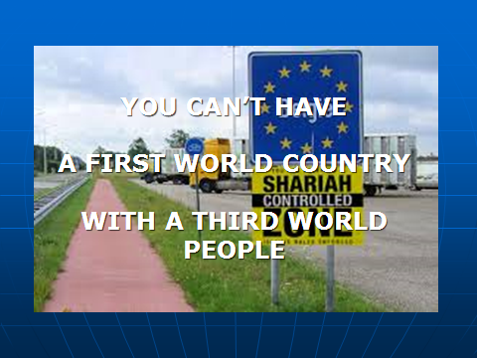

This mass immigration negatively affects European societies: rising crime, immigrant riots in European cities, major ‘white’ urban exodus out of neighborhoods that are dominated by immigrants, the import of barbarian practices like forced marriages, honor killings, the ritual slaughter of animals and female genital mutulation, a decrease of the level of education, a growing number of unemployed immigrants in our cities and increasing government expenses. This is not surprising. You can’t have a First World Country with a Third World people.

The Western World is being invaded. Not by an armed militia, but by millions of pauperized immigrants. The growth through immigration is three times higher than the natural growth.

While the native European population shrinks, there is still an enormous population growth in third world countries. While, sixty years ago, there were three times as many Europeans as there were black Africans, there are now already more black Africans than Europeans. According to predictions, by 2030, for every European there will be almost two black Africans. At the current pace, the population of black Africa will amount to one billion by 2017 and to 1.3 billion by 2030.

If Europe does not stand up to the immigration invasion and install a strict immigration policy, the European population threatens to be overrun by a tsunami of pauperized third world immigrants.

Dear friends,

Another threat Europe faces is the possible Turkish accession to the European Union. In 1987, Turkey applied for EU membership. At first, Greece pronounced its veto, but stopped its resistance in 1999. Ever since, Turkey has been an official candidate member state of the EU. Since 2005, the EU has been negotiating with Turkey on a possible accession. Granting Turkey EU membership would be a fatal mistake. On January 1st 2010, the 27 member states of the EU counted a total of 501 million inhabitants. The accession of a non-European Muslim country with almost 80 million inhabitants (about one sixth of the total population of the EU) is pure madness. During hundreds of years, Europe had to protect its eastern borders against Turkish imperialism. It wasn’t until the 19th century that southern Europe was almost completely freed from the Turkish invaders.

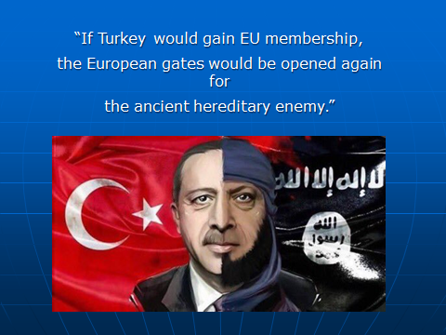

If Turkey would gain EU membership, the European gates would be opened again for the ancient hereditary enemy.

If Turkey would become an EU member, this would not only provoke an additional mass immigration of millions of people, but it would also imply that a powerful Islamic country can influence European policy.

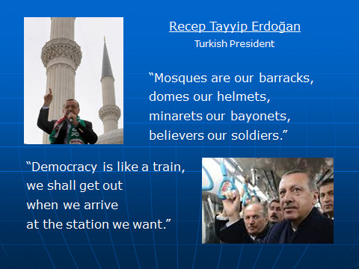

Furthermore, it is important to note that since 2003, Turkey is being governed by Islamic fundamentalists. Turkey’s prime-minister Tayyip Erdogan showed his true face when he said in 1997 (before entering government): “*Mosques are our barracks, domes our helmets, minarets our bayonets, believers our soldiers.*” and “*Democracy is like a train, we shall get out when we arrive at the station we want.*”

Dear friends,

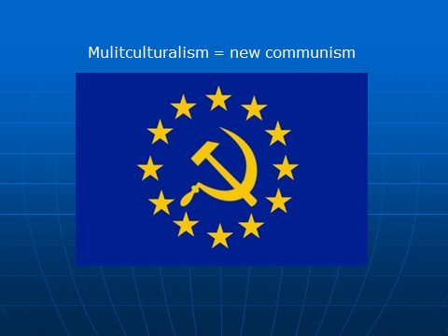

In the 80’s and 90’s, we were pleased to witness the fall of communism. In Western Europe, however, communists have now turned into so-called anti-racists. The anti-racist multicultural struggle has now replaced the communist class struggle. Immigrants and other so-called minority groups have replaced the working class proletariat. In recent years, the working class changed political sides. The left-wing parties, however, embraced the immigrant population. Eventually, the objectives of communism and multiculturalism are the same. Both strive for the equality of cultures and people and want to create a new type of human, that is no longer determined by its cultural environment, but raised according to multicultural principles.

The anti-racist struggle has replaced the proletarian revolution while discrimination has become the surrogate for the repression of the working class. These discriminated minorities of course need to be emancipated, raised and especially undergo multiculturalist brainwashing. After the Soviet Union collapsed and the terrible crimes that took place during communist rule were revealed, this ideology lost its credibility. The New Left made use of the immigration problems to dress communism up as something new.

In order to weaken our Western civilisation, several guilt complexes are being cultivated. Racism, violence, anti-Semitism, slavery, colonialism and xenophobia are represented as the West’s original sins. For this reason, the European people have lost their right to a proper identity, culture and way of living. The European nation states are harmful anachronisms and responsible for anything that goes wrong in this world. The multicultural ideology has become some sort of new religion with the equality of cultures as greatest dogma. The cure for this European disease is obvious: open the gates of Europe for the pauperized masses from third world countries. Mass immigration as ‘widergutmachung’ for colonization. Our society needs to be reprogrammed according to multicultural prescriptions. “Institutional racism” needs to be tracked down and eliminated. The entire population has to be re-educated to make them more politically-correct.

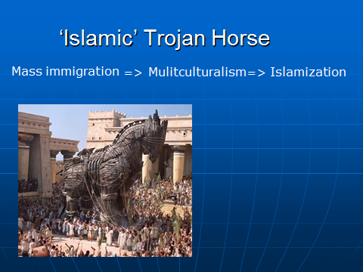

Meanwhile, multiculturalism and mass immigration have become the Trojan horse of Islamization. Millions of Muslims and their families came to live in Europe while multiculturalism encourages Islam and, under the guise of freedom of religion, put it on equal terms with European religions.

Dear friends,

Islam is taking over Europe.

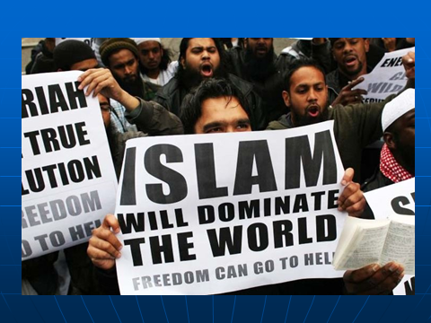

It is the fastest growing religion on the ‘Old Continent’. While Western Europe counted between one and two million Muslims in the 1960’s, this number has risen to more than 50 million today. Mosques and Koran schools flood our cities. Islamic customs and symbols – from ritual slaughters over headscarves to Islamic holidays – are authorized, made official and treated equally as the traditions of our European civilization.

More and more headscarves and djellabas pop up in the streets of every major European city. Neighborhoods and districts turn into Islamic ghettos where there is no sign of integration let alone assimilation. The Islamization is a new form of colonization that steadily changes Europe into Eurabia.

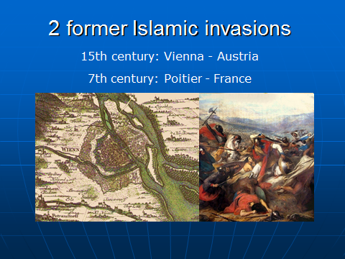

Islam is Europe’s oldest enemy. Islam is a religion of conquest that tried two times to subjugate Europe. The first invasion took place in the seventh century . Spain, Portugal and even the south of France were conquered by Islam. It wasn’t until 732 that Charles Martel stopped the march of Islam in Poitiers. It would last another 800 years to drive away Islam from southern Europe. The crusades were actually defensive wars, in order to prevent a new Islamic invasion. The reconquista came to an end in 1492, when the last Islamic troops fled from Granada towards the other side of the Mediterranean Sea. In the fifteenth century, when the Ottoman Turks attacked Europe from the East, our continent was besieged a second time. This second invasion was stopped at the gates of Vienna, in 1683. Today, we are under attack again. The third Islamic invasion is taking place as we speak with terrorist attacks in Madrid, London, Paris, Brussels and Berlin.

This third invasion isn’t about real warfare. Of course, there is a terrorist threat. However, more disturbing is the ticking demographic time bomb. For more than 40 years millions of Muslims are ‘peacefully’ overrunning Europe. Through mass immigration, conversion, propaganda and family reunification, Islam is marching on.

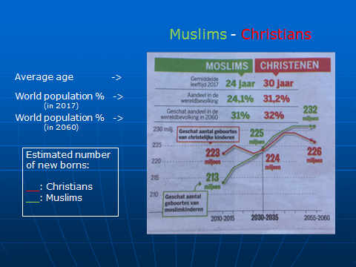

The world’s Muslim population is expected to increase by 35 % in the next 20 years, rising from 1,6 billion in 2010 to 2,2 billion by 2030. It is estimated that about 18 million Muslims live legally in Western Europe. When taking the number of illegal aliens into account, Western Europe counts more than 20 million Muslims. In Eastern Europe, a similar evolution is taking place. In the whole of Europe, Russia included, there are officially more than 50 million Muslims. Projections show that the Muslim share of the European population is expected to grow by nearly one-third over the next twenty years: from 50 million now to 73 million, in 2030.

Worldwide Islam will be the first religion. At the moment 24% of the world population are Muslims and 31% are Christians. In 2060 32% will be Muslims and 31% will be Christians.

Dear friends,

Islam is like a predator. It only attacks weak preys. Europe is weak. Europe is on the verge of extinction, losing its identity and culture and becoming an economic giant on clay feet. Europe is not only committing demographic suicide, but is terrified to defend the norms and values of European civilization.

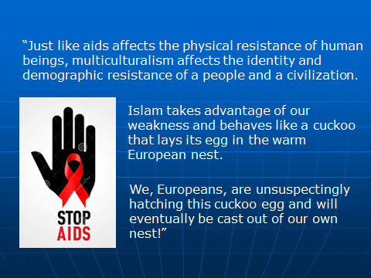

Just like aids affects the physical resistance of human beings, multiculturalism affects the identity and demographic resistance of a people and a civilization. Islam takes advantage of our weakness and behaves like a cuckoo that lays its egg in the warm European nest. We, Europeans, are unsuspectingly hatching this cuckoo egg and will eventually be cast out of our own nest!

Because of multiculturalism, Europe stays blind for the threatening danger of Muslim fundamentalism. Since the eighties, several extremist groups have infiltrated Europe. Governments and Security Agencies never interfered.

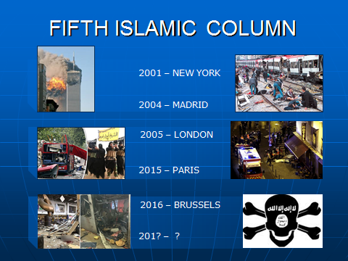

This way, the European nations allowed a fifth Islamic column to come into existence on European soil. These extremist organizations not only planned terrorist attacks on European soil, but also spread fundamentalist ideas among the growing Muslim communities in Europe. It is not surprising that the attacks in New York, Madrid, London, Paris, Brussels, Berlin, Stockholm and Brussels – as well as many failed terrorist attacks – were the work of Muslims of the second generation with French, Belgian and English passports that lived in the Western world.

Dear friends,

Europe is at war with Islam. Over the past three years, 27 Islamic State successful terrorist attacks were committed in Europe. 451 people were killed and more than 1500 were wounded.

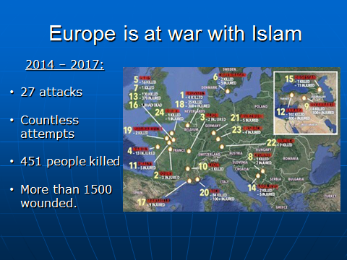

Most Muslim extremists, however, do not commit terrorist attacks but conduct their Jihad through conversions, infiltration, agitation, intimidation and undermining Western civilization. Rejecting terrorism isn’t a question of principle in Islamic circles, but a question of tactics.

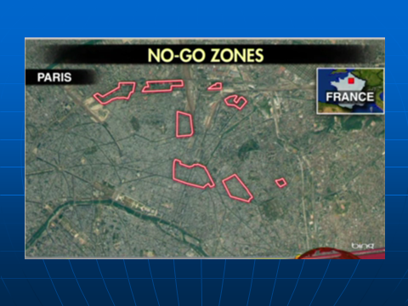

Meanwhile, the Muslim enclaves in European cities are getting bigger and bigger. The authorities can hardly maintain control over these areas. Fundamentalist Muslims use these Muslim ghettos as a beachhead for the conquest of the entire society. This ‘ghetto strategy’ allows the fundamentalists to control the Muslim community and apply the sharia, the Islamic law system. The democratic rule of law is replaced by an Islamic rule, based on the sharia. In the suburbs of Paris, where riots often take place, there are more than 700 no go zones according to official instances, zones where the French authorities have almost completely lost control. These ghetto communities are breeding grounds for Muslim terrorists and beachheads of Islamic fundamentalism.

Dear friends,

The cowardly refusal of the elite to defend our own culture and civilisation, or to propagate our identity, has become the Achilles heel not only of Europe but indeed of the entire West.

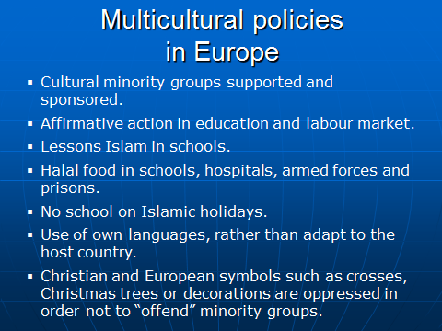

Let me give you some examples of the multicultural policies in Belgium and other European countries:

* Cultural events and activities by and for minority groups are supported and sponsored.
* Affirmative action in education and in the labour market is encouraged.
* The teaching package in schools are extended to lessons in minority religions, particularly Islam.
* The food habits of minority cultures and religions is accommodated in institutions such as schools, hospitals, the armed forces and prisons.
* Absenteism of minority pupils, due to religious or other special days related to their ancestral culture, is tolerated.
* Minorities are helped to continue to use their own languages, rather than them having to adapt and learn the language of the host country.
* Christian and European symbols such as crosses, Christmas trees or decorations are taken away in order not to “offend” certain minority groups.

The supporters of multiculturalism are in control of the social debate. This is not a surprise. They control the European politics and media.

Dear friends,

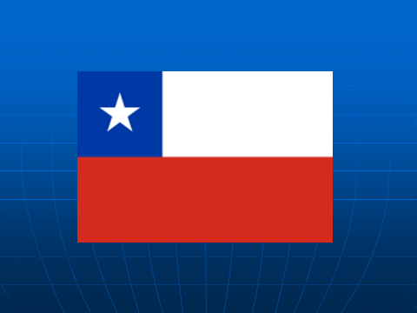

I am aware that in recent years, Chile’s economic growth and stability have made it an attractive destination for other South Americans, and also for migrants from the Dominican Republic, Venezuela and Haïti to immigrate to Chile. Nevertheless immigration to Chile remains low proportionally compared to other developed countries. Although immigration to Chile is low, Chile’s outdated immigration laws are responsible for importing problems like delinquency, drug trafficking and organised crime!

In Europe a secularized post-Christian culture is facing a fast growing Muslim community. South-America, unlike secular Europe, has remained rooted to a larger extent in traditional Christian values. I do not doubt that if these values continue to decline in South-America, Chile risks to be within some decades in the same situation as Europe is now. However, Chile can learn from the ongoing European catastrophe, and avoid a similar fate. Let this be a call to you Chile to protect and preserve our Western values and to controll your borders.

Dear friends,

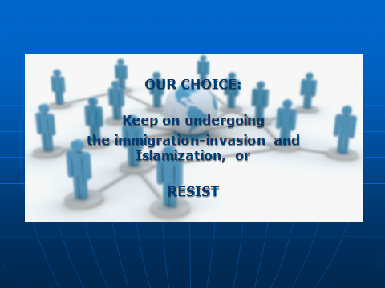

In Europe we have to make a choice: keep on undergoing the immigration invasion and islamization, or resist. Protecting our national identity and cultural singularity does not imply that we must seclude ourselves from all other cultures and external influences. Gradual and controlled interaction is the way ahead. Accordingly, the admission of a limited number of migrants may be beneficial. It should be clear that the pursuit of ethnic purity is out of the question.

But so too, for any realistic person, is the present disastrous shambles, in which genuine cultural interaction is being replaced by a third world invasion and even Islamic expansionism. The motto of today’s Western rulers may be 'diversity', but in practice many different and often clashing cultures are forced into coexistence on the same territory.

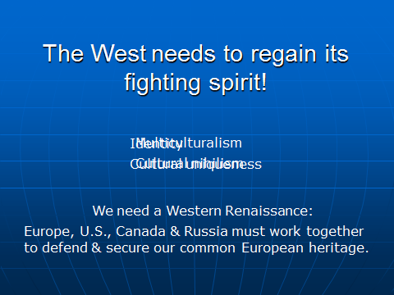

The West needs to regain its fighting spirit. A Western Renaissance is only realistic if we get out of the multicultural straitjacket, renounce cultural nihilism, get back our identity and cultural uniqueness and dare to recognize the superiority of our Western civilization.

In this context is it regrettable that countries that are part of our Western or European civilization often seek to damage or even destabilize other countries of this community for the sake of their own short term (often economic) interests. The peoples belonging to our European civilization - Europe U.S., South-America, Canada and Russia - must work together in order to defend and secure our common identity and our common European heritage.

Dear friends,

The problems of Europe are also the problems of the United States and even the problems of Russia. In order to save our Western and European civilisation, we need to regain control over their borders and stop the immigration invasion. The immigration policy needs to be based on the social and cultural safety of our Western and Christian civilization.

It is time to stop the renunciation of our own identity. How can we expect immigrants to adjust to a society that we disrespect ourselves? How can we expect immigrants to try to fit into a society that is, according to multiculturalists, ‘racist’? How can we expect immigrants and Muslims to assimilate to a culture that does not believe in - and stand up for - its own values?

Dear friends,

What we first need is a strict immigration policy. People who want to start new lives in our countries must first show that they bring skills and attitudes that will make a positive contribution to our society.

Secondly, the West must start a civilizational moral offensive, based on the foundations of our greatness: Rome, Greece, Christianity and (real) Humanism. These are the common European values that need to be promoted.

Foreigners wanting to settle here must show loyalty to their host society and the principles of our civilisation. And they must know that they have to adjust to OUR way of living and NOT the other way around.

Dear friends,

My father used to tell me a story when I was still a child. He told me that he named me Filip after “Filips van de Elzas”. Filips van de Elzas was the King of Flanders during the 13th century. He was one of the leaders of the 3rd crusade.

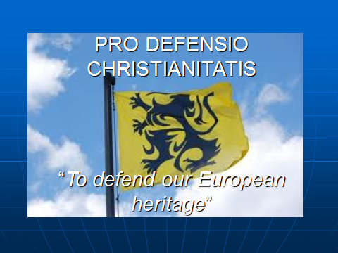

The legend says that he brought home to Europe from the Holy Land, Jeruzalem, the symbol of the black lion on a golden field after fighting a Saracen Muslim knight. His motto during this crusade was “Pro Defensio Christianitatis” – To defend our Christian and European heritage”. Let the motto of the King of Flanders during the 3rd crusade also be our message today!

Thank you for your kind attention.

Filip Dewinter